

**www.DeniPsDesigns.com**

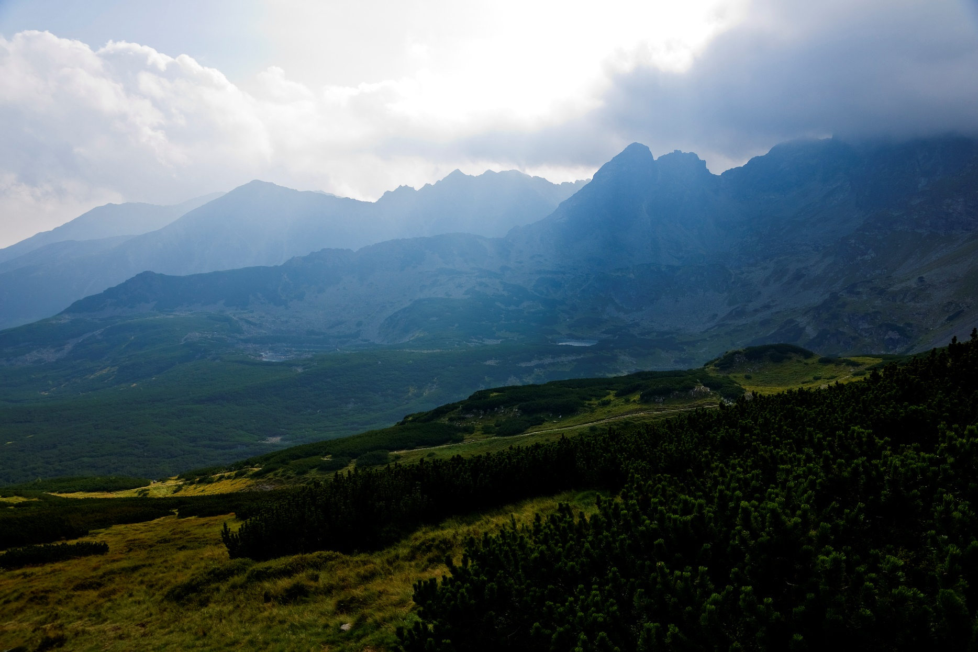

**“****And each one will be like a hiding place from the wind. . .  
Like the shadow of a massive crag in a parched land.”**

**Thank you, Brother.**

For the hard work and loving care you have shown us!

Look! A king[+](http://wol.jw.org/en/wol/bc/r1/lp-e/1001061127/763) will reign for righteousness,

And princes will rule for justice.

And each one will be like a hiding place from the wind,

A place of concealment from the rainstorm,

Like streams of water in a waterless land,

Like the shadow of a massive crag in a parched land.

Then the eyes of those seeing will no longer be pasted shut,

And the ears of those hearing will pay attention.

—Isaiah 32:1-3