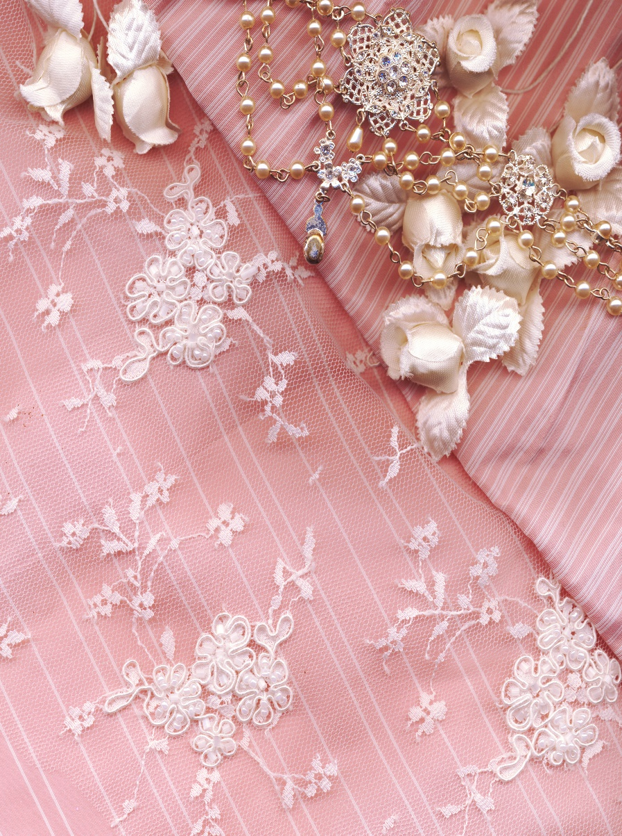

**On   
Your   
Wedding Day**