“Observe intently the birds of heaven;   
they do not sow seed or reap   
or gather into storehouses,   
yet your heavenly Father feeds them.   
**Are you not worth more than they are?**Who of you by being anxious   
can add one cubit to his life span?

—Matthew **6:26, 27**

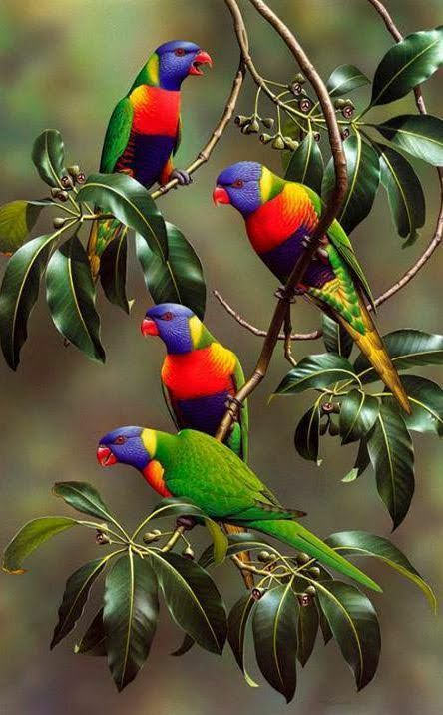



**“Are You Not Worth   
More Than They Are?”**

**“A true friend shows love at all times and is a brother who is born for times of distress.”̶̶**

**—Proverbs 17:17**