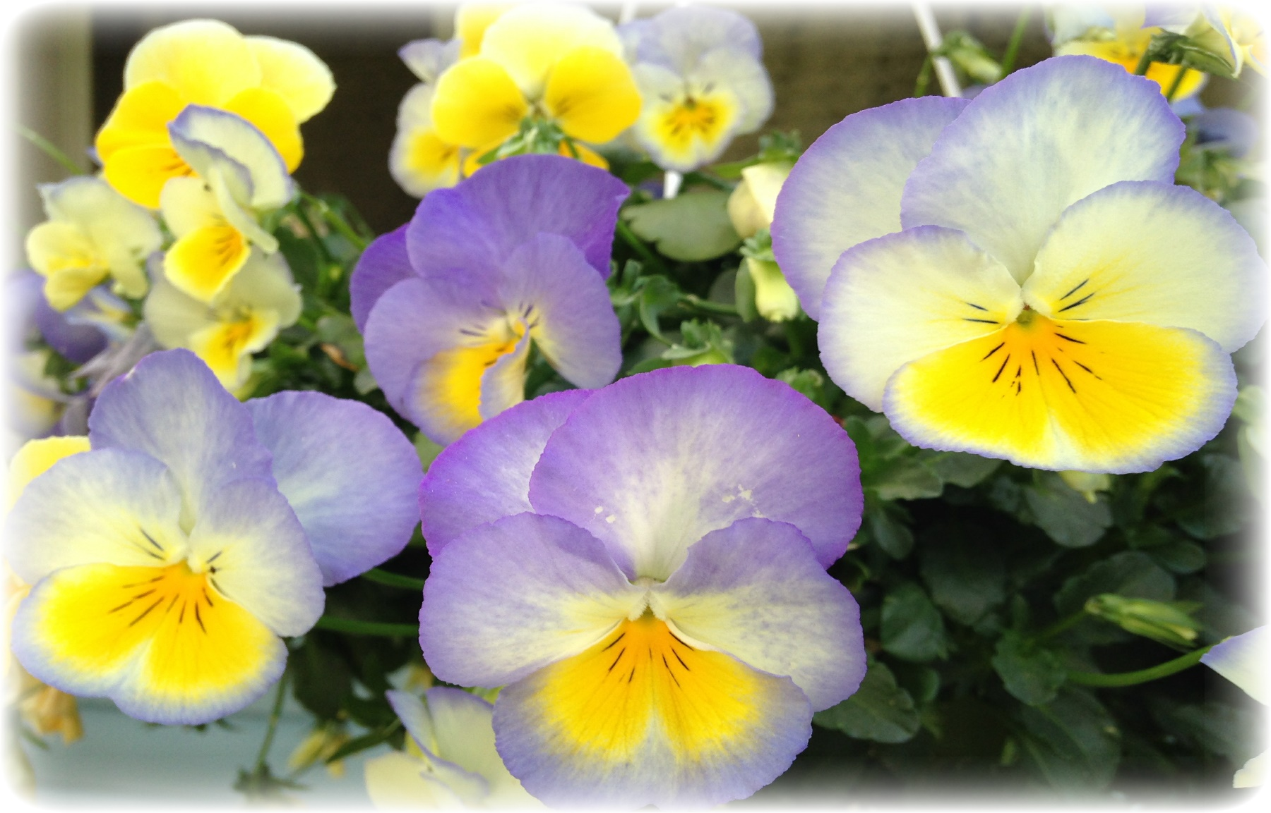



www.DeniPsDesigns.com

**Happy 50th   
Anniversary**