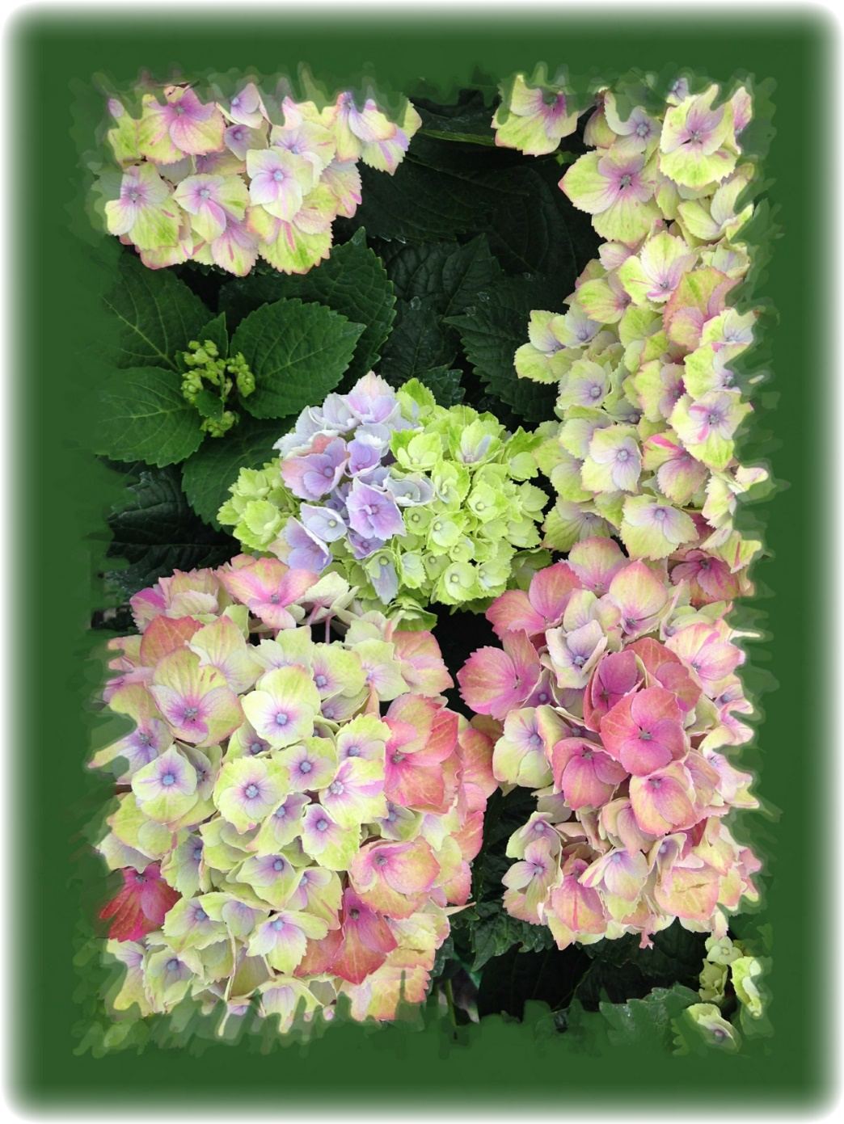



**www.DeniPsDesigns.com**

**Anniversary**

**Happy**