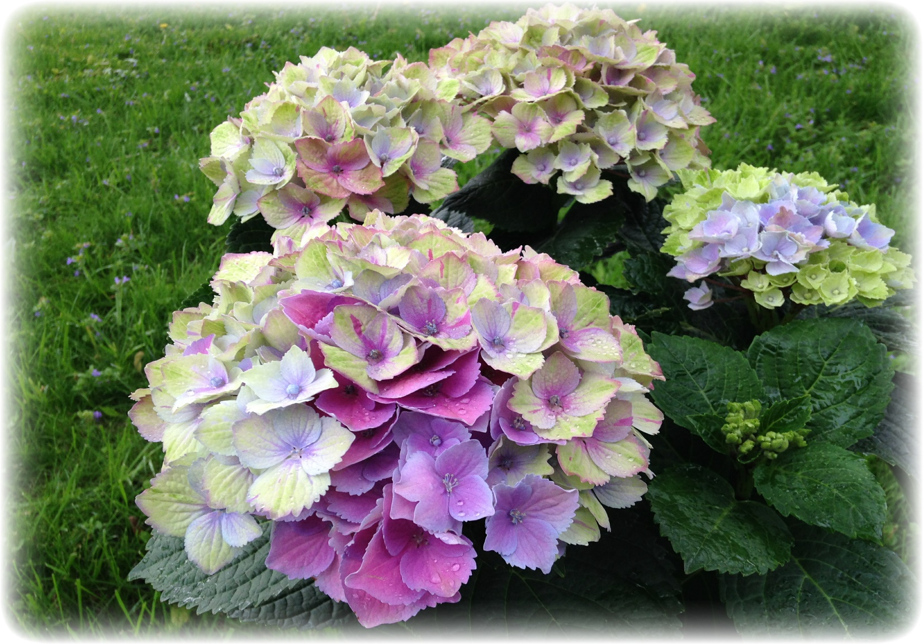

**I Am   
Sick**

**(Isaiah 33:24)**

**No Resident Will Say**



**www.DeniPsDesigns.com**