**“Look! A body of water;   
what prevents me   
from getting baptized?”**

(Acts 8:36)

So glad you decided to   
‘seek Jehovah’   
and join ‘Jehovah’s Army’  
On this Special Day in your new life!

_________________________________

“Do not be afraid, for I am with you. Do not be anxious, for I am your God.I will fortify you, yes, I will help you, I will really hold on to you with my right hand of righteousness.’”**—Isaiah 41:10**

For I, Jehovah your God, am grasping your right hand,The One saying to you, ‘Do not be afraid. I will help you.’**—Isaiah 41:13**

“Your strength will be in keeping calm   
and showing trust.” **—Isaiah 30:15**

“Those seeking Jehovah will lack nothing good.”  
**—Psalm 34:10**(2022 Yeartext)

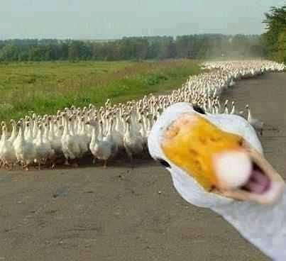

**“Jehovah gives the command; The women proclaiming the   
good news are a large army.”**

**—Psalm 68:11**

**“A true friend shows love at all times and is a brother who is born for times of distress.”̶̶**

**—Proverbs 17:17**