

**Love Never Fails**

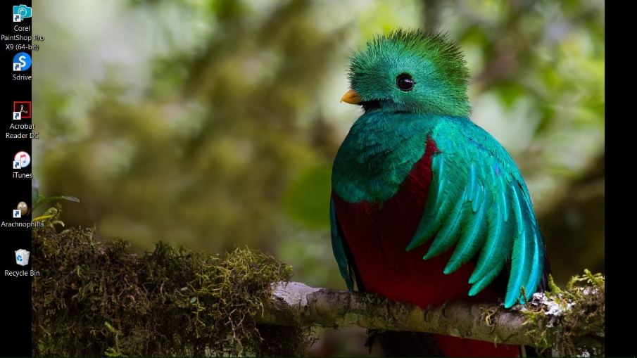

Looking Good!