**“Do not be afraid,**

**for I am with you.**

**Do not be anxious,**

**for I am your God.**

**I [Jehovah] will fortify you, yes,**

**I will help you,**

**I will really hold on to you with my right hand of righteousness.”**

— **Isaiah 41:10**



**Love Never Fails**

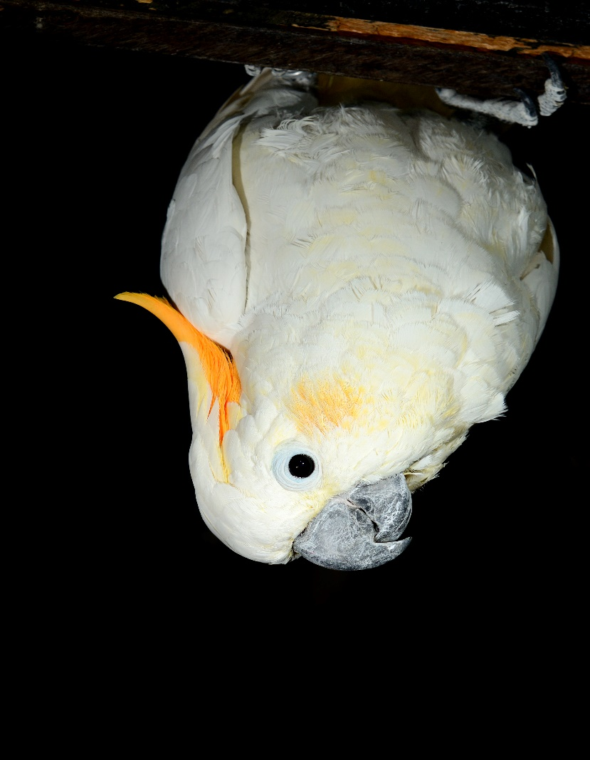

**Jehovah will fortify you.**

**Do not be anxious,**