

**So glad nothing prevented you!!**

**May Jehovah richly bless you  
for making the changes in your life  
that enable you to serve him   
from this day  
  
forward into the new world!**

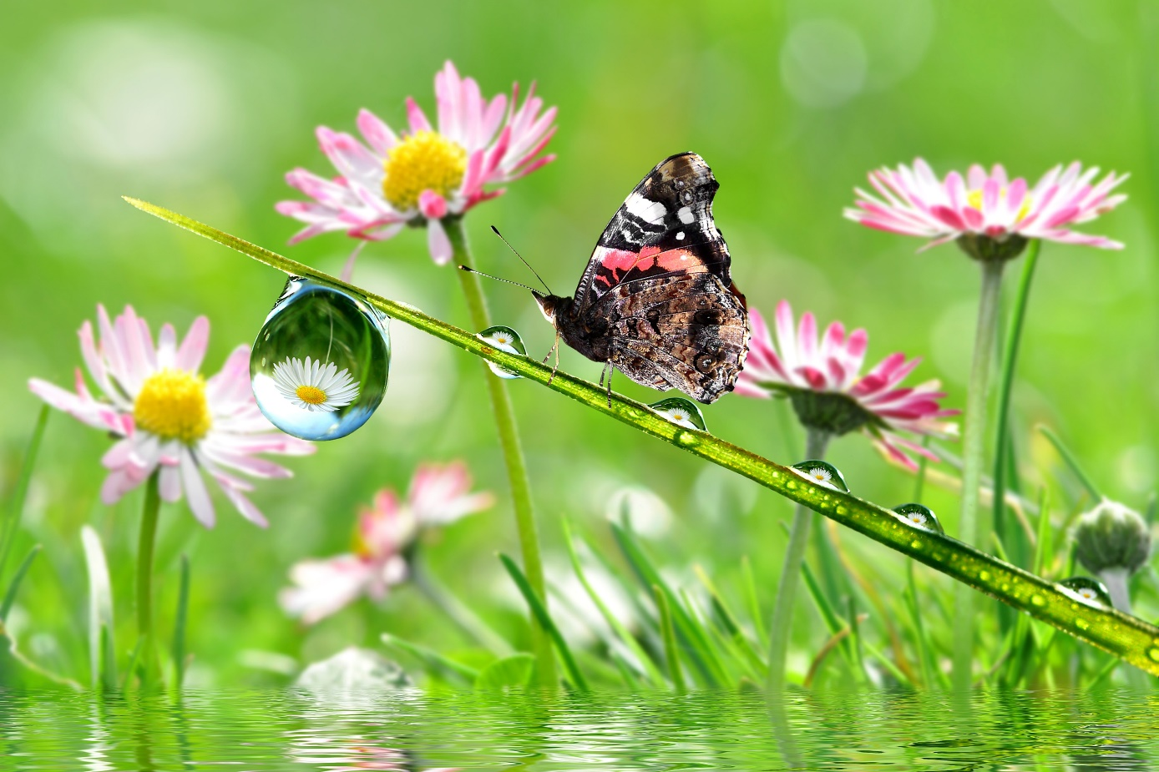

**“Look! A body of water; what prevents me from getting baptized?”**

**—Acts 8:36**

**Serve Jehovah with rejoicing.**

**Come into his presence with joyful shouting.**

**—Psalm 100:2**