

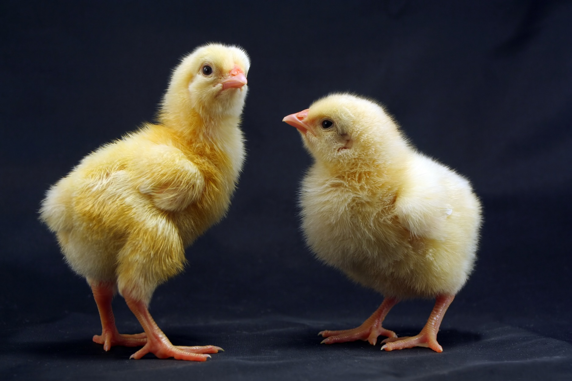

**Happy 50th Anniversary**

**Right chick:** “Hey good lookin’! What’cha got cookin’?” (wolf whistles)

**Left chick:** “Oh dear. Where’re your glasses? We’re not ‘spring chickens’  anymore, sweetie.”

**Right chick:** “So? We ***will be*** again! ***Happy Anniversary!***”

**Left chick:** “***NOW*** you remember it after 53 (?) years?”