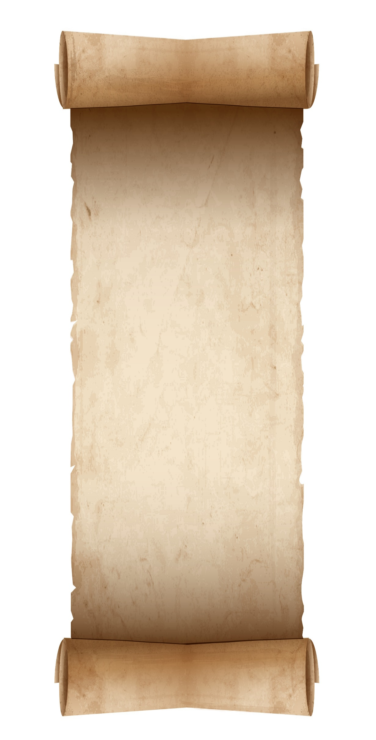

2025

Bible Reading

Jan 6 Psalms 127-134

13 Psalms 135-137

20 Psalms 138-139

27 Psalms 140-143

Feb 3 Psalms 144-146

10 Psalms 147-150

17 Proverbs 1

24 Proverbs 2

Mar 3 Proverbs 3

10 Proverbs 4

17 Proverbs 5

24 Proverbs 6

31 Proverbs 7

Apr 7 Proverbs 8

14 Proverbs 9

21 Proverbs 10

28 Proverbs 11

May 5 Proverbs 12

12 Proverbs 13

19 Proverbs 14

26 Proverbs 15

**“Give Jehovah   
the glory due   
his name.”**

**—Psalm 96:8**



2025

Bible Reading

Jan 6 Psalms 127-134

13 Psalms 135-137

20 Psalms 138-139

27 Psalms 140-143

Feb 3 Psalms 144-146

10 Psalms 147-150

17 Proverbs 1

24 Proverbs 2

Mar 3 Proverbs 3

10 Proverbs 4

17 Proverbs 5

24 Proverbs 6

31 Proverbs 7

Apr 7 Proverbs 8

14 Proverbs 9

21 Proverbs 10

28 Proverbs 11

May 5 Proverbs 12

12 Proverbs 13

19 Proverbs 14

26 Proverbs 15

**“Give Jehovah   
the glory due   
his name.”**

**—Psalm 96:8**

June 2 Proverbs 16

9 Proverbs 17

16 Proverbs 18

23 Proverbs 19

30 Proverbs 20

July 7 Proverbs 21

14 Proverbs 22

21 Proverbs 23

28 Proverbs 24

Aug 4 Proverbs 25

11 Proverbs 26

18 Proverbs 27

25 Proverbs 28

Sep 1 Proverbs 29

8 Proverbs 30

15 Proverbs 31

22 Ecclesiastes 1-2

29 Ecclesiastes 3-4

Oct 6 Ecclesiastes 5-6

13 Ecclesiastes 7-8

20 Ecclesiastes 9-10

27 Ecclesiastes 11-12

Nov 3 Song of Solomon 1-2

10 Song of Solomon 3-5

17 Song of Solomon 6-8

24 Isaiah 1-2

Dec 1 Isaiah 3-5

8 Isaiah 6-8

15 Isaiah 9-10

22 Isaiah 11-13

29 Isaiah 14-16

DeniPsDesigns.com

June 2 Proverbs 16

9 Proverbs 17

16 Proverbs 18

23 Proverbs 19

30 Proverbs 20

July 7 Proverbs 21

14 Proverbs 22

21 Proverbs 23

28 Proverbs 24

Aug 4 Proverbs 25

11 Proverbs 26

18 Proverbs 27

25 Proverbs 28

Sep 1 Proverbs 29

8 Proverbs 30

15 Proverbs 31

22 Ecclesiastes 1-2

29 Ecclesiastes 3-4

Oct 6 Ecclesiastes 5-6

13 Ecclesiastes 7-8

20 Ecclesiastes 9-10

27 Ecclesiastes 11-12

Nov 3 Song of Solomon 1-2

10 Song of Solomon 3-5

17 Song of Solomon 6-8

24 Isaiah 1-2

Dec 1 Isaiah 3-5

8 Isaiah 6-8

15 Isaiah 9-10

22 Isaiah 11-13

29 Isaiah 14-16

DeniPsDesigns.com