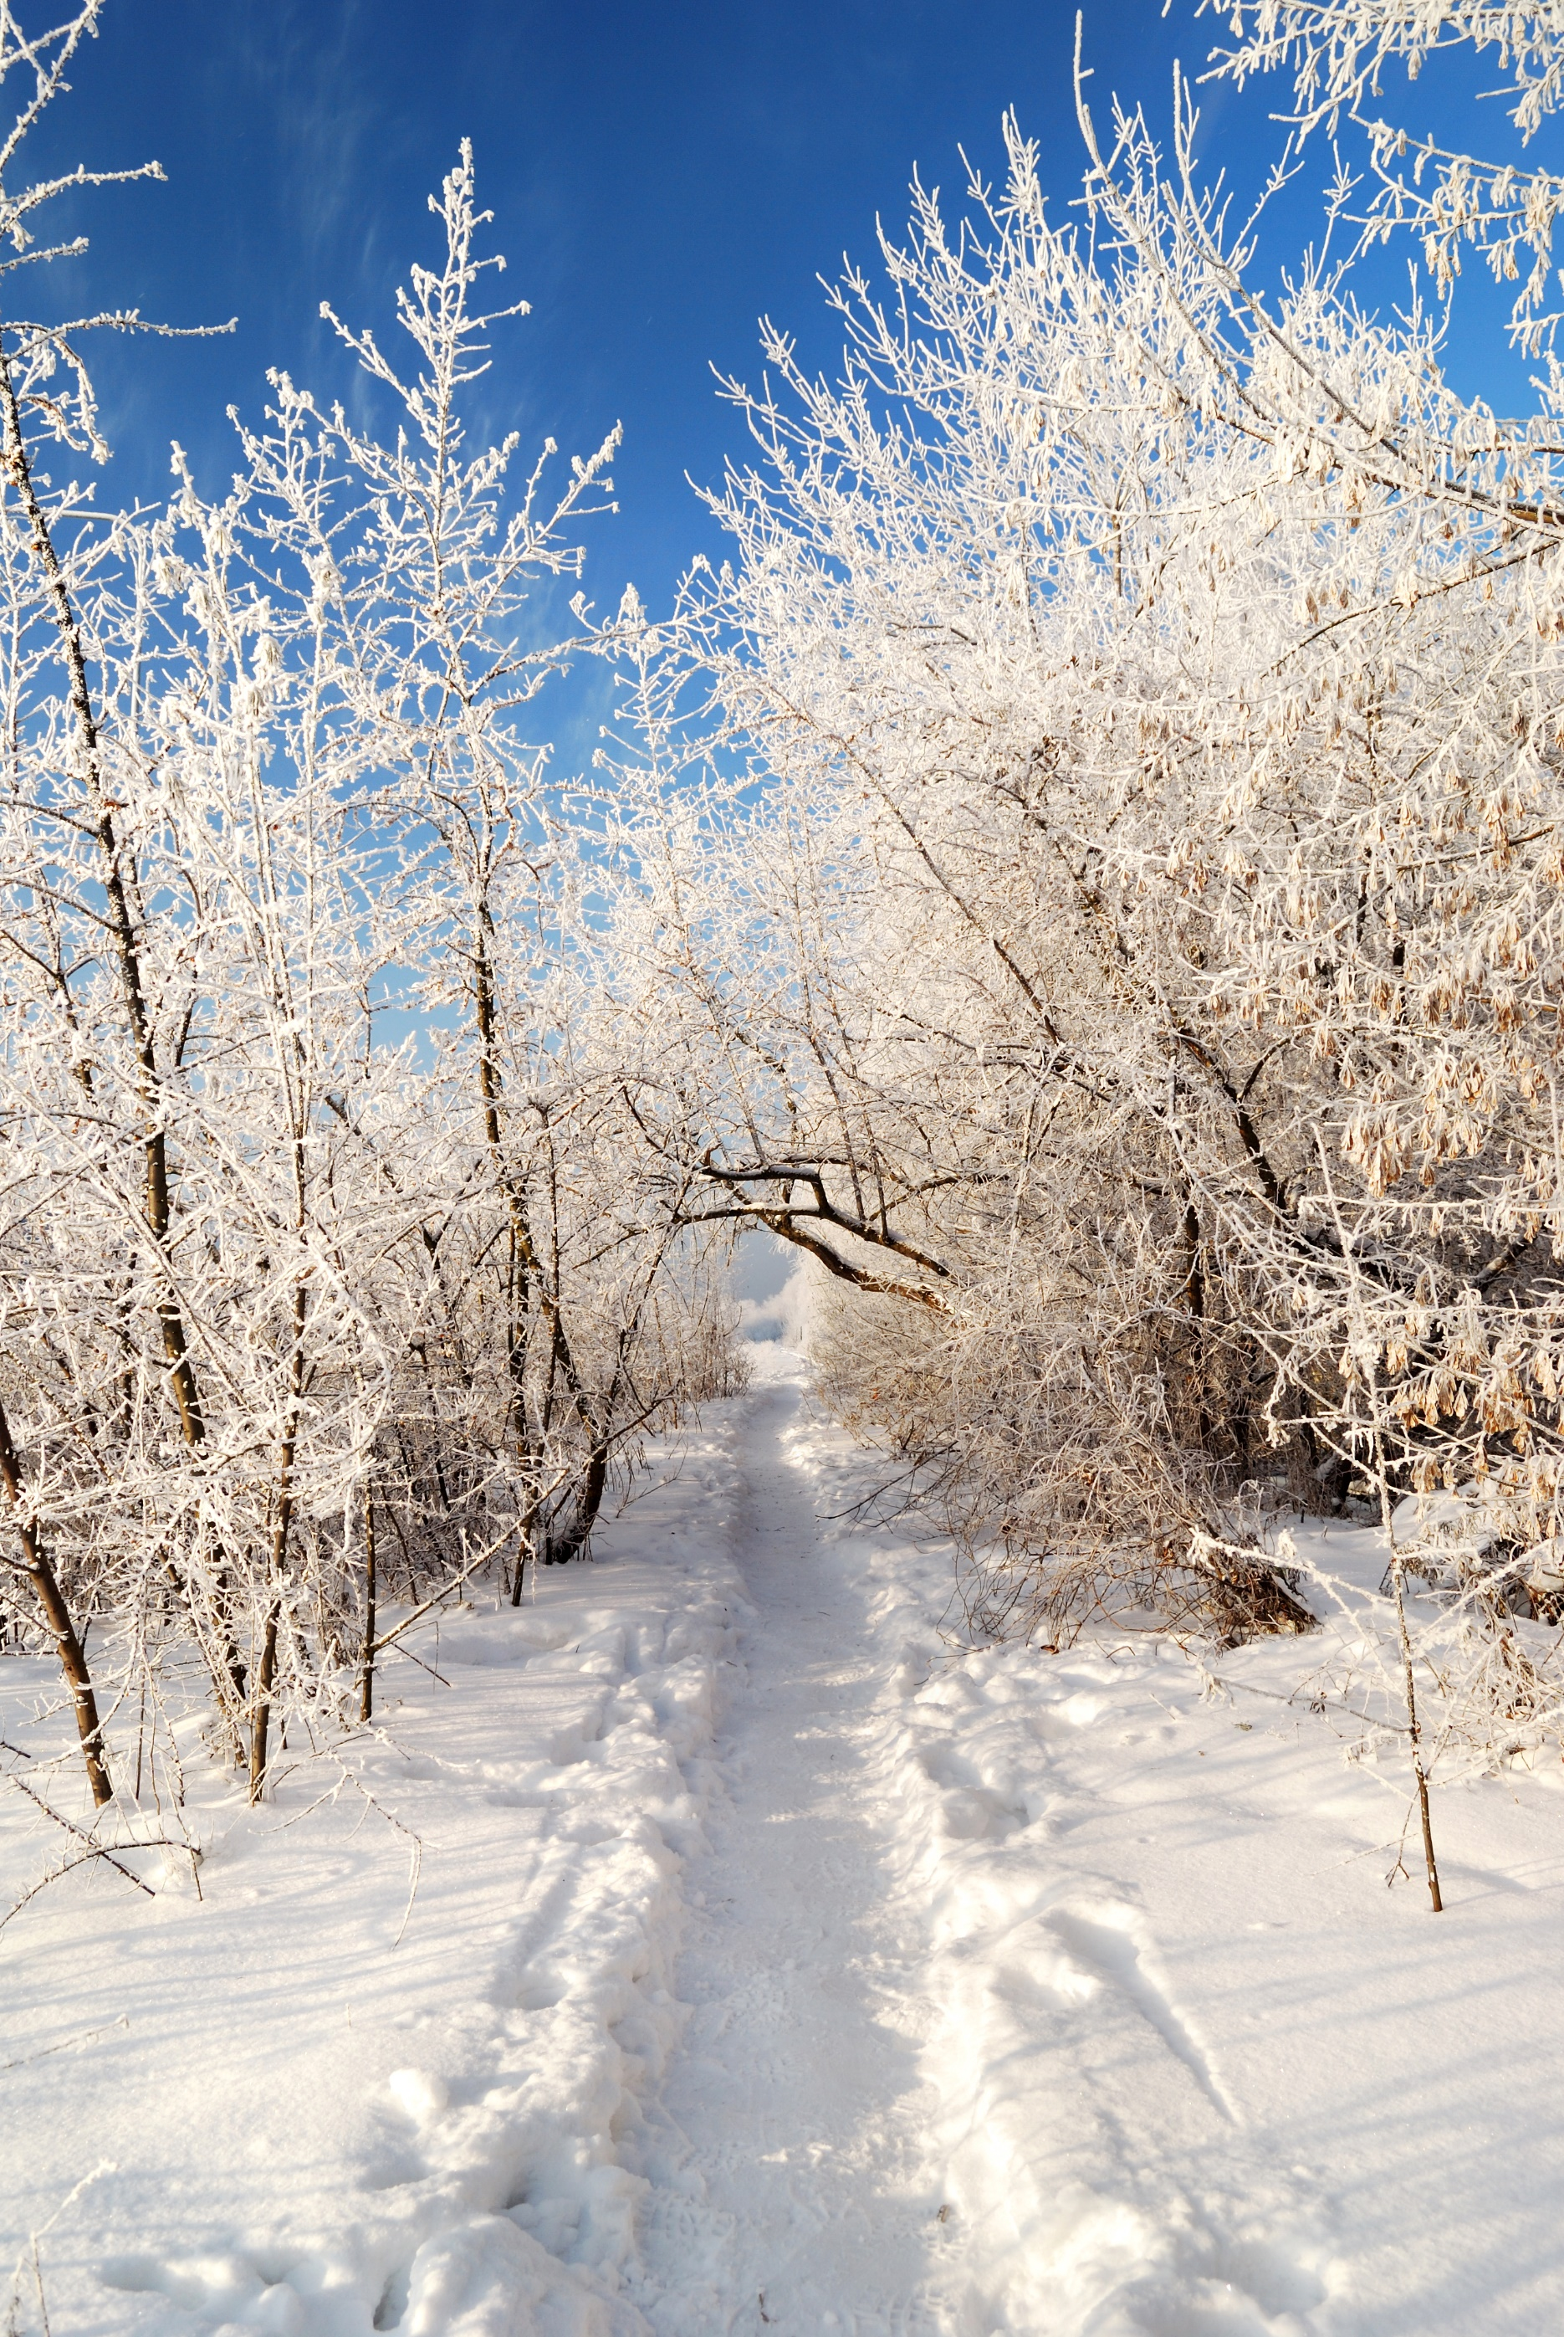

2024

**“When I am afraid, I put my trust in you.”**

**—Psalm 56:3**

2024

**“When I am afraid, I put my trust in you.”**

**—Psalm 56:3**

Jan 1 Job 32-33

8 Job 34-35

15 Job 36-37

22 Job 38-39

29 Job 40-42

Feb 5 Psalms 1-4

12 Psalms 5-7

19 Psalms 8-10

26 Psalms 11-15

Mar 4 Psalms 16-17

11 Psalm 18

18 Psalms 19-21

25 Psalm 22

Apr 1 Psalms 23-25

8 Psalms 26-28

15 Psalms 29-31

22 Psalms 32-33

29 Psalms 34-35

May 6 Psalms 36-37

13 Psalms 38-39

20 Psalms 40-41

27 Psalms 42-44

June 3 Psalms 45-47

10 Psalms 48-50

17 Psalms 51-53

24 Psalms 54-56

July 1 Psalms 57-59

8 Psalms 60-62

15 Psalms 63-65

22 Psalms 66-68

29 Psalm 69

Aug 5 Psalms 70-72

12 Psalms 73-74

19 Psalms 75-77

26 Psalm 78

Sep 2 Psalms 79-81

9 Psalms 82-84

16 Psalms 85-87

23 Psalms 88-89

30 Psalms 90-91

Oct 7 Psalms 92-95

14 Psalms 96-99

21 Psalms 100-102

28 Psalms 103-104

Nov 4 Psalm 105

11 Psalm 106

18 Psalms 107-108

25 Psalms 109-112

Dec 2 Psalms 113-118

9 Psalm 119:1-56

16 Psalm 119:57-120

23 Psalm 119:121-176

30 Psalms 120-126

DeniPsDesigns.com

Jan 1 Job 32-33

8 Job 34-35

15 Job 36-37

22 Job 38-39

29 Job 40-42

Feb 5 Psalms 1-4

12 Psalms 5-7

19 Psalms 8-10

26 Psalms 11-15

Mar 4 Psalms 16-17

11 Psalm 18

18 Psalms 19-21

25 Psalm 22

Apr 1 Psalms 23-25

8 Psalms 26-28

15 Psalms 29-31

22 Psalms 32-33

29 Psalms 34-35

May 6 Psalms 36-37

13 Psalms 38-39

20 Psalms 40-41

27 Psalms 42-44

June 3 Psalms 45-47

10 Psalms 48-50

17 Psalms 51-53

24 Psalms 54-56

July 1 Psalms 57-59

8 Psalms 60-62

15 Psalms 63-65

22 Psalms 66-68

29 Psalm 69

Aug 5 Psalms 70-72

12 Psalms 73-74

19 Psalms 75-77

26 Psalm 78

Sep 2 Psalms 79-81

9 Psalms 82-84

16 Psalms 85-87

23 Psalms 88-89

30 Psalms 90-91

Oct 7 Psalms 92-95

14 Psalms 96-99

21 Psalms 100-102

28 Psalms 103-104

Nov 4 Psalm 105

11 Psalm 106

18 Psalms 107-108

25 Psalms 109-112

Dec 2 Psalms 113-118

9 Psalm 119:1-56

16 Psalm 119:57-120

23 Psalm 119:121-176

30 Psalms 120-126

DeniPsDesigns.com