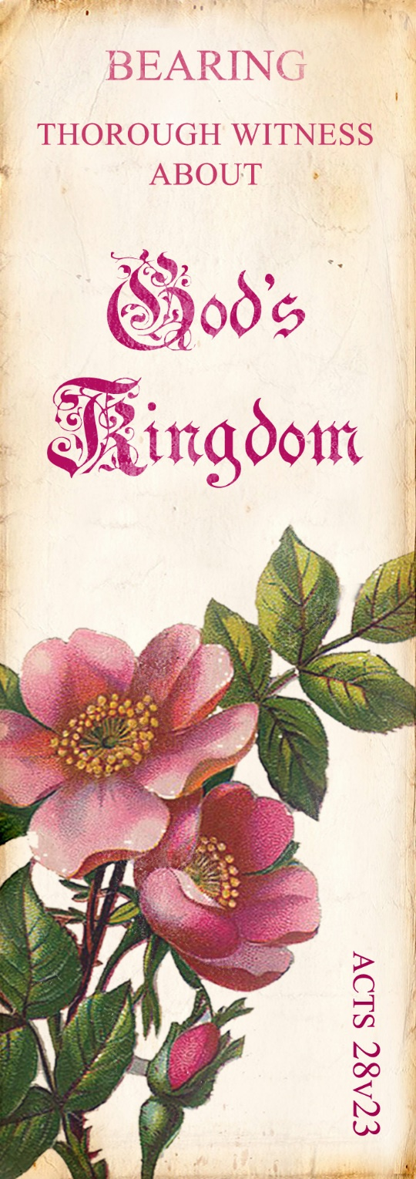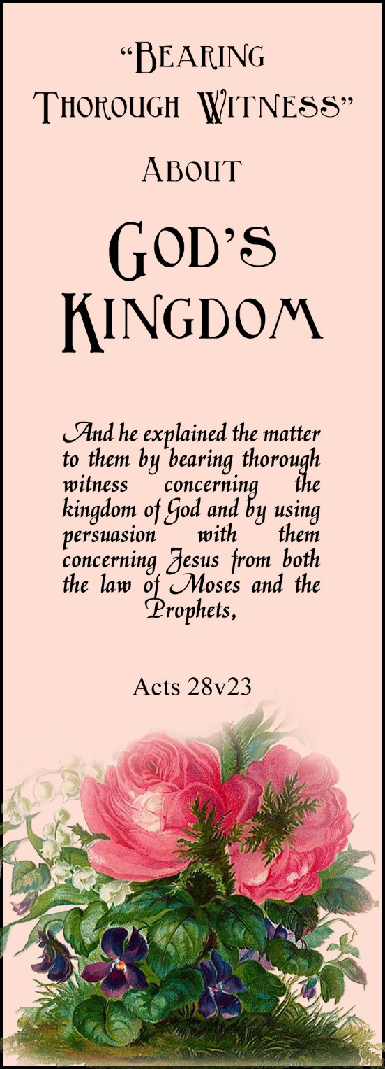

**2024**

**Jan 1 chap. 4 box on p. 30**

8 chap. 4 box on p. 33

15 chap. 4 ¶9-12, box on   
p. 34

22 chap. 4 ¶13-20

29 chap. 5 ¶1-8, box on   
p. 39

**Feb 5 chap. 5 ¶9-15, box on p. 41**

12 chap. 5 ¶16-22, box on p. 42

19 chap. 6 ¶1-8 and intro to section 2

26 chap. 6 ¶9-17

**Mar 4 chap. 6 ¶18-24, box on p. 48**

11 chap. 7 ¶1-8, box on   
p. 53

18 chap. 7 ¶9-13, box on   
p. 56

25 chap. 7 ¶14-18, boxes on pp. 57-58

**Apr 1 chap. 8 ¶1-4, boxes on pp. 61-62**

8 chap. 8 ¶5-12

15 chap. 8 ¶13-21

22 chap. 8 ¶22-24, box on p. 67

29 chap. 9 ¶1-7, intro to section 3, and box on p. 70

**\*\* Cover Art by Saffron Delights \*\***

DeniPsDesigns.com

**2024**

**Jan 1 chap. 4 box on p. 30**

8 chap. 4 box on p. 33

15 chap. 4 ¶9-12, box on   
p. 34

22 chap. 4 ¶13-20

29 chap. 5 ¶1-8, box on   
p. 39

**Feb 5 chap. 5 ¶9-15, box on p. 41**

12 chap. 5 ¶16-22, box on p. 42

19 chap. 6 ¶1-8 and intro to section 2

26 chap. 6 ¶9-17

**Mar 4 chap. 6 ¶18-24, box on p. 48**

11 chap. 7 ¶1-8, box on   
p. 53

18 chap. 7 ¶9-13, box on   
p. 56

25 chap. 7 ¶14-18, boxes on pp. 57-58

**Apr 1 chap. 8 ¶1-4, boxes on pp. 61-62**

8 chap. 8 ¶5-12

15 chap. 8 ¶13-21

22 chap. 8 ¶22-24, box on p. 67

29 chap. 9 ¶1-7, intro to section 3, and box on p. 70

**\*\* Cover Art by Saffron Delights \*\***

DeniPsDesigns.com

**2024**

**Jan 1 chap. 4 box on p. 30**

8 chap. 4 box on p. 33

15 chap. 4 ¶9-12, box on   
p. 34

22 chap. 4 ¶13-20

29 chap. 5 ¶1-8, box on   
p. 39

**Feb 5 chap. 5 ¶9-15, box on p. 41**

12 chap. 5 ¶16-22, box on p. 42

19 chap. 6 ¶1-8 and intro to section 2

26 chap. 6 ¶9-17

**Mar 4 chap. 6 ¶18-24, box on p. 48**

11 chap. 7 ¶1-8, box on   
p. 53

18 chap. 7 ¶9-13, box on   
p. 56

25 chap. 7 ¶14-18, boxes on pp. 57-58

**Apr 1 chap. 8 ¶1-4, boxes on pp. 61-62**

8 chap. 8 ¶5-12

15 chap. 8 ¶13-21

22 chap. 8 ¶22-24, box on p. 67

29 chap. 9 ¶1-7, intro to section 3, and box on p. 70

**\*\* Cover Art by Saffron Delights \*\***

DeniPsDesigns.com

**2024**

**Jan 1 chap. 4 box on p. 30**

8 chap. 4 box on p. 33

15 chap. 4 ¶9-12, box on   
p. 34

22 chap. 4 ¶13-20

29 chap. 5 ¶1-8, box on   
p. 39

**Feb 5 chap. 5 ¶9-15, box on p. 41**

12 chap. 5 ¶16-22, box on p. 42

19 chap. 6 ¶1-8 and intro to section 2

26 chap. 6 ¶9-17

**Mar 4 chap. 6 ¶18-24, box on p. 48**

11 chap. 7 ¶1-8, box on   
p. 53

18 chap. 7 ¶9-13, box on   
p. 56

25 chap. 7 ¶14-18, boxes on pp. 57-58

**Apr 1 chap. 8 ¶1-4, boxes on pp. 61-62**

8 chap. 8 ¶5-12

15 chap. 8 ¶13-21

22 chap. 8 ¶22-24, box on p. 67

29 chap. 9 ¶1-7, intro to section 3, and box on p. 70

**\*\* Cover Art by Saffron Delights \*\***

DeniPsDesigns.com